Towards a Strategy for Economic Growth in Uruguay

Ricardo Hausmann
Andrés Rodríguez-Clare
Dani Rodrik

November 8, 2004

I. Introduction

The Uruguayan economy is recovering from the 2002 financial crisis that disrupted its banking system, caused a collapse of its currency and seriously affected its fiscal solvency (Figure 1). The crisis was clearly associated with the collapse of the Argentine economy and its concomitant currency, banking and debt crises. Both were also related to the sudden stop that followed the Russian crisis of 1998, which prompted an important realignment of the real in January 1999, a fact that had exerted enormous pressure on bilateral exchange rates within Mercosur. The impact on Uruguay would have been severe in the best of circumstances, given the importance of Argentina’s aggregate demand and relative prices on its smaller neighbor, but the effect was amplified by the presence of Argentine troubled banks in the Uruguayan financial system. With a heavily dollarized banking system and public debt, a major real exchange rate realignment would – under any circumstance – seriously damage the solvency of the fisc and the banks. Not surprisingly, the Uruguayan economy went on a serious tailspin. It had the worst growth performance of any Latin American country in the period between 1998 and 2003 with the exception of Argentina and Venezuela.

Crisis management

Nevertheless, the political system managed the crisis with great responsibility. It avoided the behavior of Argentina in terms of violation of contracts and rules as it confronted the crisis. To manage the situation the authorities negotiated a debt exchange with its bondholders, achieved significant support from the international financial community and imposed a temporary deposit freeze on public banks. But its management of the situation left the impression that its political system – including the opposition – had behaved responsibly under the harshest circumstances and, if anything, was able to reestablish macro balance with a minimal damage to its reputation. This is reflected, among other indicators, in the fact that inflation was kept under control and quickly returned to single digits (Figure 2), frozen deposits were promptly returned and country risk has gone from acute distress levels to almost pre-crisis levels (Figure 3). Today, while Argentina is still in a state of default and has yet to get back to capital markets, Uruguay has been able to place CPI-indexed domestic-currency debt in international markets.
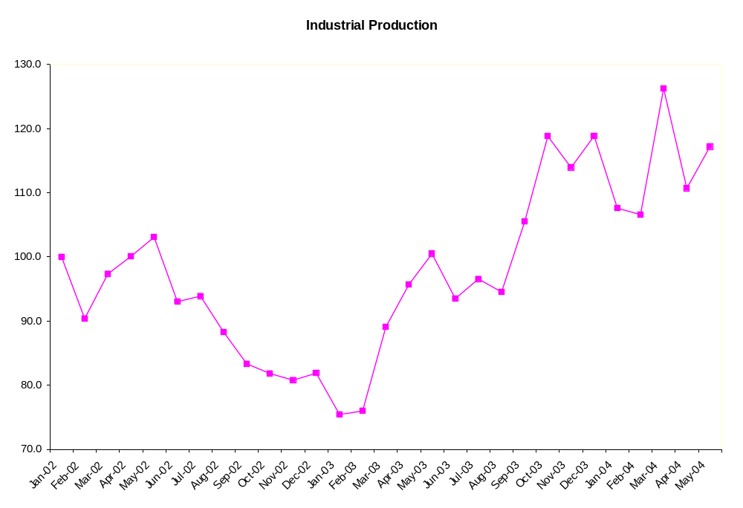
Figure 1

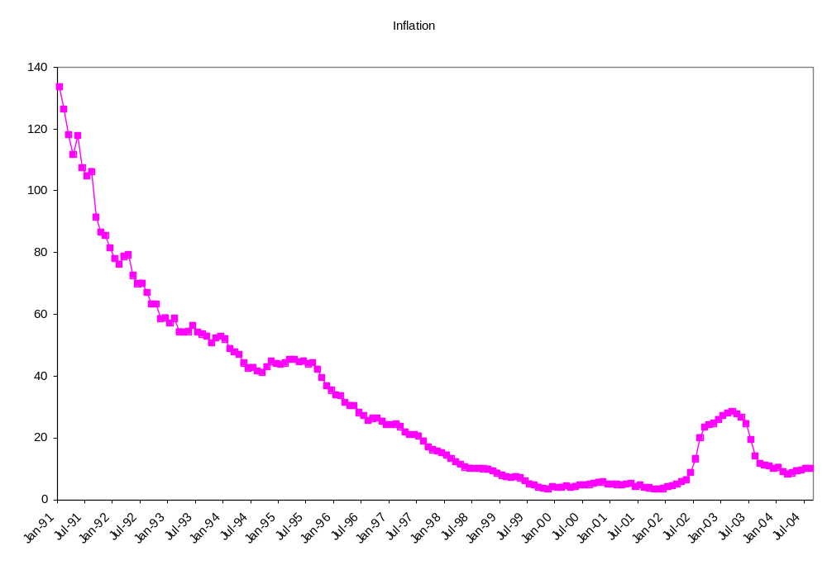

Figure 2

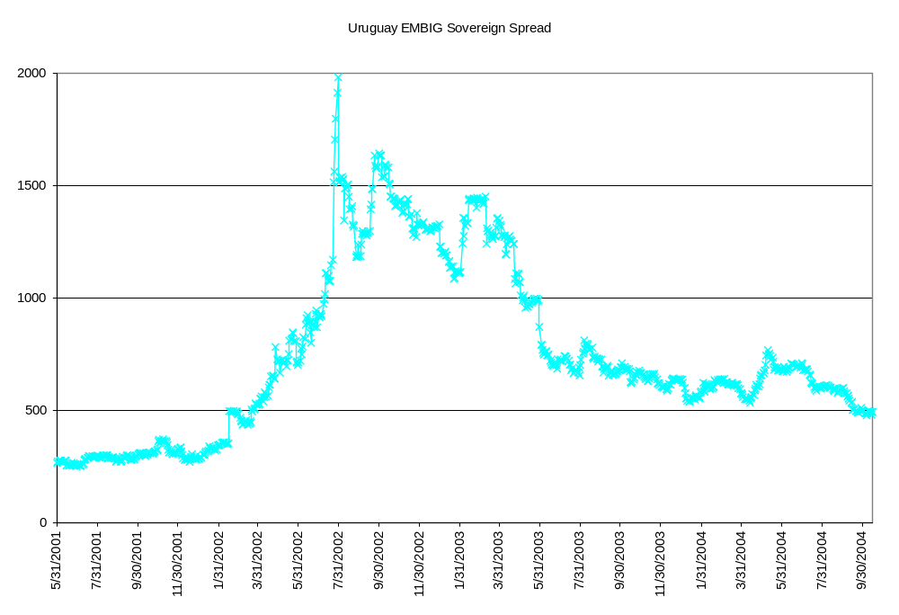
Figure 3

Macro balance has been reestablished, in spite of the weaker public debt ratios left by the crisis and the economy has been recovering since the second quarter of 2003. This must be taken as a very significant achievement of the Uruguayan polity. More surprisingly, our mission found that animal spirits have come back in full force. The new weaker level of the real exchange rate is obviously positive for the potential profitability of the tradable sector. Interestingly, in Uruguay this has led to numerous and very concrete investment opportunities which appear to have large growth potential: we found significant optimism from entrepreneurs about prospects for such products as meat, rice, soybeans, forestry, pulp and paper, ports, tourism, software and the export of business services.

New growth opportunities

The reestablishment of macro balance, a more competitive real exchange rate, and a political system and institutions that have earned credibility and trust under fire underpin each of these investment opportunities. But in addition, we found that behind each of the principal investment opportunities lies the provision of critical public goods. Meat has reappeared in the scene thanks to the capacity of Uruguay to control foot and mouth disease through improved animal sanitation and tracking techniques. Rice has benefited from a public-private partnership in seed development through INIA that has increased productivity to the highest global standards. Forestry has benefited from a consistent policy of investment subsidies and of the perceived commitment to the sector in terms of attracting the complementary investments in pulp and paper and in port infrastructure. Tourism has benefited from a consistent policy to broaden destinations, diversify markets and provide the needed infrastructure, advertisement and security. Software has benefited from the high level of public education in the country as well as from an adequate tax treatment. Overall, behind every potential new area of growth lies not only a macroeconomic and macro-institutional explanation but also the presence of good sectoral institutions and an ability of the Uruguayan polity to achieve economically effective and socially legitimate public-private cooperation.

The new areas of growth are mostly in rather traditional areas in which the country can leverage its natural advantages. One important question is why is it now that these activities appear so promising? Why were these opportunities not exploited in the last 20 years? What characteristics did the pattern of growth exhibit that explains the limits to growth in these areas?

The role of the real exchange rate

One explanation has to do with the evolution of the real exchange rate in the context of regional economic trends. The investment opportunities mentioned above involve the production of goods for global markets: agricultural products such as beef, rice, soybeans and forestry are globally traded. Their profitability depends on the international prices of those goods in US dollars and on the real exchange rate of Uruguay vis a vis the dollar. However, Uruguay is deeply integrated with Argentina and Brazil and these two countries have a powerful effect on its macroeconomy, including on its real exchange rate vis a vis the US dollar. Here it is useful to distinguish between the 1980s in the aftermath of the debt crisis and the 1990s. In the 1980s, all countries suffered significant real depreciations vis a vis the US dollar while in the 1990s they all appreciated strongly. In the case of Uruguay, after a drastic depreciation around 1982, the multilateral real exchange rate remained relatively flat (with some deflationary trend) until the end of 1990. From then on it entered a strong real appreciation trend until its crisis in 2002. By contrast, while Argentina and Brazil also exhibit these broad trends, they show much more volatility. In addition, their depreciations in the late 1990s and earlier in this decade happened at different dates. As a consequence, bilateral real exchange rates have been quite volatile. The 1990s saw a period of relatively stable bilateral real exchange rates with Uruguay’s neighbors at a rather appreciated real exchange rate, accompanied by an appreciation vis a vis the US dollar. This created incentives in favor of regional goods and against global goods and Uruguay’s tradable production was shifted towards deeper integration with Mercosur.

This pattern was first broken in January 1999 when Brazil devalued and later in December 2001 when Argentina did the same. Both events involved in addition to a shift of relative prices, an important decline in aggregate demand in the two countries. As a consequence, Uruguay was hit by a major reduction in regional demand for its goods. Adjustment required a large real depreciation vis a vis the US dollar. But with a highly dollarized financial system and public debt, the depreciation would entail serious solvency problems. However, it reestablished the conditions of profitability for its global goods sector.

This story clearly indicates that with respect to a scenario in which Uruguay only produced for the regional market, the presence of both regional and global goods makes the country more stable. When aggregate demand in Argentina and Brazil is relatively strong, buoyed say, by strong terms of trade or capital inflows, their real exchange rates appreciate vis a vis the US dollar. This demand spills over into Uruguay causing an expansionary impulse there and redirecting resources away from global goods and into regional goods. As a consequence, the real exchange rate of Uruguay vis a vis the dollar also appreciates. When demand collapses in Argentina and Brazil, the process is reversed. The presence of global goods limits the fall of Uruguayan income when the regional economy is weak, as these activities can expand while the regional goods sector necessarily contract. If Uruguay was purely specialized in global goods, it could avoid importing the volatility from its neighbors. However, it is unclear that it would maximize its wellbeing by following this strategy. Forgoing the sale of tourist, trade and financial services to Argentina and Brazil so as to avoid volatility is surely not an optimal strategy. As Uruguayans are keenly aware, the country cannot walk away from its geography. The question is simply how to manage the coexistence of these two types of markets.

The Mercosur context

During our visit we sensed that different political organizations and social groups had come up with two opposite answers to this dilemma: one is to deepen integration within Mercosur, by advancing towards a real customs union and harmonizing other policy areas. The other strategy is to limit integration into Mercosur so as to be in a position to better protect its global goods sector. This would involve negotiating a status similar to Chile’s within Mercosur so as to have the freedom to set external tariffs independently and be in a position to lower them significantly. Such a strategy would facilitate growth in the global goods sector by eliminating the anti-export bias of Mercosur protection and by limiting the importation of volatility from its neighbors. This is an important issue that we will try to address in this report.

Some of the global goods that Uruguay exports can be sold in regional markets: rice and milk are good examples. Since these goods have high protection in Brazil, Uruguay can benefit from the higher price in that market associated with Brazilian protection, which Uruguay need not pay. This should at least count as a static gain to be compared with the losses caused by imposing higher tariff barriers in order to protect Argentinean and Brazilian industry. It also shelters these sectors from the excessive volatility of the dollar real exchange rate. Other goods, such as meat are also exported by the other Mercosur countries and hence must be sold outside the region. These will suffer from the anti-export bias caused by Mercosur protectionism and by the real exchange rate volatility vis a vis the dollar that the macro instability in these countries generates.

However, during the 1990s deeper integration with Mercosur both induced real appreciation in Uruguay and cushioned the country from its negative growth effects by allowing some of the tradable activities to survive and even to expand into the protected regional market. If real appreciation was going to take place anyway, say because of the effect of Argentina’s appreciation through the demand for tourism services in Uruguay, where tariffs are not an issue, then the net effect of the trade agreement may have actually been positive for Uruguayan industry, although a free trade area agreement – a la Chile-Mercosur – would have been even better.

The growth context

Beyond macro fluctuations, it is important to gauge the determinants of the underlying growth trends of Uruguay. The recent economic history of the country is punctuated by two enormous falls in output: the 1982 debt crisis and the recent 2002 financial crisis. If we take the growth performance of Uruguay between the peak years of 1981 and 1998, the cumulative per capita growth rate was a meager 0.7 percent. If instead, one measures it from the trough of 1984 to the trough of 2002 growth in per capita income was 1.1 percent.

In the longer period between the peak-years of 1956 and 1998, per capita growth was 1 percent. According to the World Development Indicators growth, between 1960 and 1998 was 0.9 percent. Since growth in the US was about 2 percent, this means that between 1960 and 1998 Uruguay’s per capita income fell from 28.3 percent of the US average to 19.0 percent.

We conclude that roughly speaking long run per capita growth has averaged about 1 percent which implies that the country has been growing less than the technological frontier over a long period of time.

What are the proximate causes of this lackluster performance? If we focus on the relatively benign decade of the 1990s, one characteristic that emerges is low investment, which averaged barely 15.4 percent for the decade, a full 7.4 percentage points less than would be expected based on the country’s income per capita. Was this caused by lack of investible resources (low supply of savings) or lack of investment opportunities (low investment demand). One answer to this question comes from looking at whether the country had fully used its available sources of external savings. This was obviously not the case as the current account deficit barely averaged 1.4 percent of GDP for the decade while the country enjoyed an investment-grade credit rating. Hence, it had access to relatively cheap sources of finance that it decided not to mobilize. We conclude that on the whole the low investment ratio reflected low demand for investment.

This means that the risk-adjusted return to physical capital was low. Could this be explained by a lack of complementary inputs such as human capital or institutions? Clearly, it could not have been human capital. As Figure 4 shows, the country exhibits a rather high level of schooling but very low returns to schooling. This is the opposite of what would be expected if the country had bumped into a human capital constraint.

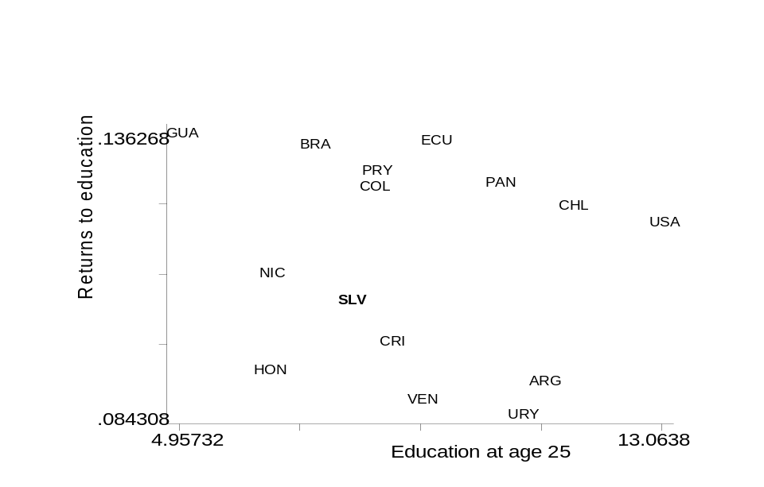
Figure 4

Neither does Uruguay seem to suffer from inadequate institutions. The country averaged a 1.74 index in the Kaufman rule of law indicator. This compares to 0.23 for Argentina, -0.16 for Brazil and 0.26 expected for countries of Uruguay’s level of income.

One possible explanation is the instability of the growth environment and in particular of the real exchange rate. Figure 5 shows the ranking of 73 countries in terms of the volatility of their 5-year real exchange rate in the period between 1980 and 2000. The country appears as the 8th most volatile. This increases the risk and lowers investment in the tradable sector for any expected level of the real exchange rate. In addition, it lowers the expected return of R&D and public goods investments in the sector. Thus real exchange rate volatility may explain why so many investment opportunities remain unexploited in traditional export areas in Uruguay and these only appear at very weak levels of the real exchange rate.

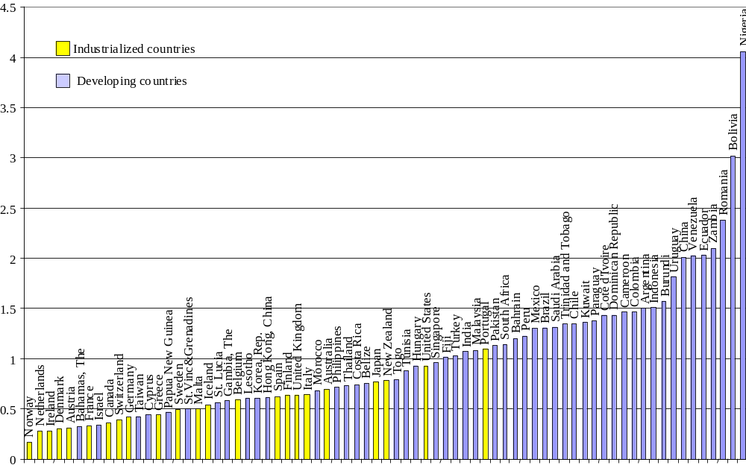
Figure 5: Five-year volatility of the real exchange rate

Another explanation, which we will discuss in this report, is the presence of externalities in the process of discovering new profitable activities, especially in the tradable sector, a process which we refer to as self-discovery. In general, expending resources in the process of finding out whether, some activities, after some adaptation to local conditions, can be profitably produced in Uruguay is bound to generate information that is valuable to other potential producers, who will benefit from these efforts. This means that part of the payoff to self-discovery efforts benefits third parties and consequently depresses the market return to these activities. As a consequence, the market will make an inefficiently low effort from a social point of view.

The process of self-discovery will be further disrupted by real appreciation and by real exchange rate volatility: the appreciation acts as a general tax as it lowers the expected pay-off while the volatility increases the risk of this already perilous activity.

Is the check in the mail?

Macro balance has been largely achieved although not in a fully resilient manner, given fiscal and banking weaknesses. Inflation is at single digits and country risk is below 500bp. The level of the real exchange rate makes the country quite competitive. There are ample underutilized productive assets that can be deployed given a growing world economy and a rapidly recovering regional market. In addition, there are clear ideas about areas of profitable private investment with large growth potential. The political system is working well and new authorities have just been elected. In short, Uruguay is well placed to embark on a process of rapid and significant recovery. In some sense, the check of recovery is clearly in the mail.

One question is whether this will be converted this time into sustained growth. Can the country improve on its 1 percent long-run rate of growth of per capita GDP? We can offer an encouraging metaphor. The current situation of Uruguay is not unrelated to that of Chile in 1984. The country had seen a drop in GDP of 18 percent over the two previous years. The public debt exceeded 100 percent of GDP. Savings rates were low. However, starting that year, the country embarked on a sustained expansion with growth exceeding 7 percent on average for the following 14 years, compared to less than 4 percent for Uruguay in the same period. Growth was led by exports, which were quite intensive in Chile’s natural endowment. Savings rates gradually increased by over 6 percentage points of GDP and the public debt to GDP ratio declined to less than 20 percent of GDP. One major difference between the two countries is that in Chile, the real exchange rate depreciation that took place in the context of the 1982 crisis was much more sustained than in Uruguay. We conjecture that this allowed the economy to provide greater incentives for the development of a globally productive export sector. By contrast, real appreciation in Uruguay was related to the pull of an appreciating regional market that proved unsustainable.

The future of Uruguay

Can Uruguay change its lackluster and volatile growth path? Will it need to abandon its prevailing social compact in order to do so? We think that growth can be accelerated within the existing social compact. While the Uruguayan system has involved a more activist state than has been fashionable of late, it has been able to generate a solid democracy and public institutions that are able to deliver the necessary public goods for the development of new growth activities, such as the ones mentioned above. Our strategy is based on leveraging the institutional advantages of the country and its political traditions and focusing it in facilitating and accelerating productive transformation.

Life is full of surprises and opportunities may arise in unplanned areas. The development strategy should be open to this possibility. However, the investment ideas that the market seems to be encouraging prefigure a growth path based on natural resource-based industries and niche services. Meat, rice, forestry, pulp and paper, dairy products and software appear well poised for sustained expansion. As mentioned above, the potential of each one of these sectors and of others such as tourism and financial services is predicated on the provision of key public goods and high quality institutions.

Implementing a strategy to accelerate growth inevitably involves interventions at both the macro and the micro level. At the micro level, the idea is to make it as easy as possible for society to transform its productive structure through the development of growth and investment opportunities. This requires addressing informational or coordination problems that arise, especially in new activities. Developing the institutional capacity to do this efficiently and legitimately is key. The macro level involves the maintenance of a stable and competitive real exchange rate, so as to create a stable and encouraging environment for export growth. Without a more stable set of relative price expectations, it will be difficult to consolidate the process of growth.

In what follows we take up each of these elements of the growth strategy. We first focus on the design of incentive policies for economic diversification and promotion. We discuss next the macroeconomic complements, with special emphasis on maintaining a competitive and stable real exchange rate.

II. Targeting institutional strengths more closely on productive transformation

As we have discussed in the preceding section, Uruguay’s institutions are relatively effective in the provision of a wide range of public goods. These public goods—a competent, honest bureaucracy, public safety, law and order, health and sanitary standards, research and extension services in some agricultural areas, functioning democratic procedures, social cohesion—play an important role in strengthening the country’s traditional areas of comparative advantage. They will also play a key role in defining new areas of comparative advantage and diversifying the productive structure. We believe that these assets can be deployed more effectively, both by recognizing their contribution to productive renewal and by understanding the requirements of economic diversification.

Why economic transformation requires a proactive government stance

Economic growth is synonymous with the accumulation of productive assets and productive capabilities. Markets play a critical role in the provision of incentives for such accumulation. They generate the profitability signals to which entrepreneurs, investors, households, and workers respond. When such signals are wrong or are diluted—through the distortion or repression of markets—the economy cannot live up its potential and economic growth remains low.

Markets can malfunction both when governments interfere too much and when they interfere too little. Development policies of the last two decades have been obsessed with the first category of policy mistakes—governments’ errors of commission. Hence the efforts to reduce or eliminate regulations, trade restrictions, financial repression, and public ownership. Governments’ errors of omission—needed interventions that were not supplied—were de-emphasized, in part as a reaction to the strong emphasis placed on them by the earlier (and out-of-fashion) policies of import substitution. A more balanced strategy has begun to emerge recently, as most of the liberalized economies have failed to deliver a satisfactory performance.

The liberal, free-market paradigm of economic development contends that economic transformation is best fostered when the government takes a hands-off attitude to the real economy and keeps producers at arms’ length. The historical and empirical record is sharply at variance with this view. Economic success is more often than not the result of collaborative private-public strategies. The role that public support for new industries has played in the economic powerhouses of East and Southeast Asia is well known. But closer to home, the same is true also of the comparatively fewer successes that have emerged in Latin America. See, for example, the Table below which lists the top 5 export items of three Latin American countries—Brazil, Chile, and Mexico—to the United States market. Leaving aside traditional exports, practically all of the export successes have been shaped in some part by public policies. Aircraft and steel in Brazil were the subject of explicit industrial policies, through trade restrictions and subsidies. In Chile, grapes and fish were boosted early on by publicly funded R&D and dissemination activities, and forestry products have a long history of subsidized plantations. In Mexico, motor vehicles and electronics are the creation of the maquila program and tariff preferences granted under the NAFTA. Scratch the surface of non-traditional export success stories, and more often than not you will find industrial policies, public R&D, sectoral supports, export subsidies, or preferential tariff arrangements lurking beneath the surface.

Top 5 export items (HS4) to the U.S. (in 2000)
Country | Item | Value ($ mil)
Brazil | aircraft | 1,435
 | shoes | 1,069
 | non-crude petroleum | 689
 | steel | 485
 | chemical woodpulp | 465
Chile | copper | 457
 | grapes | 396
 | fish | 377
 | lumber | 144
 | wood | 142
Mexico | motor vehicles | 15,771
 | crude oil | 11,977
 | computers & peripherals | 6,411
 | ignition wiring sets | 5,576
 | trucks | 4,853

Uruguay is no exception to this. While the specific stories differ, in most cases, new economic activities have been the result of public-private collaboration—of private entrepreneurship plus public incentives and support. Forestry and tourism have benefited from generous tax incentives; rice from INIA’s research; beef from publicly run sanitation and tracking systems; logistics, banking, software, and call centers from the tax exemptions granted in zona francas. What Uruguay needs is a strategy to render this interaction more systematic and more effective. To develop such a strategy, we require in turn a solid understanding of the market failures that block the emergence of new industries and the strengthening of existing ones. These are covered in the next two subsections.

  - Informational externalities and horizontal policies for self-discovery

Markets are pretty good at signaling the profitability of activities that already exist, but poor at uncovering the profitability of activities that might exist but do not. Even if these activities are not new in the sense that they are present in other, richer economies, they confront potential producers with considerable uncertainty as regards costs and productivity under local conditions. Breaking into these new sectors typically requires a pioneer investor, who signals to other investors the profitability of these new activities. We call this process of discovery of the underlying cost structure of the economy “self discovery” (Hausmann and Rodrik 2003).

The self discovery process is rife with information externalities because the cost information discovered by an entrepreneur cannot be kept private. If the pioneer is profitable, this can be readily observable by others. Imitative entry then follows, the incumbent’s rents are dissipated, and a new sector takes off. If, on the other hand, the pioneer firm goes bankrupt, the losses are borne in full by the entrepreneur. Hence entrepreneurship of this kind is not a very rewarding economic activity: the losses are private while the gains are socialized. Consequently markets underprovide entrepreneurship in new activities. But the social benefits of self-discovery are huge: for a small economy like Uruguay, finding a few products which can be profitably produced for world markets can make the difference between prosperity and stagnation. Generating incentives for self discovery should therefore be a key objective of economic policy.

During our visit to Uruguay, we did see examples of self-discovery at work. In Zonamerica, we observed several firms operating small, experimental call centers to test whether Uruguayan workers had the language and other skills that would make it profitable to invest in Uruguay. Effectively, these firms were in the process of self discovery: they were uncovering the true costs of operating in the Uruguayan environment. If and when they are successful, they provide valuable information to other firms and facilitate further investment in this area in Uruguay. A potentially even more significant example is provided by the entry of Tata Consultancy Services. As the minister of finance put it, “Tata is the best advertising for us.” Once Tata demonstrates that Uruguay is a profitable location for the provision of software and business services, it provides an important demonstration effect to other foreign firms. A somewhat similar process seems to have taken place earlier in banking: Merill Lynch was the first big bank to invest in Zonamerica. Once it came, others followed.

The challenge is to strengthen the process of self discovery by multiplying these examples. We highlight several shortcomings of the Uruguayan policy regime that stand out from this perspective. First, at present, there is no systematic, pro-active strategy of going after investments in new areas. Investment promotion remains a passive, ad hoc, idiosyncratic affair. Tata for example seems to have come to Uruguay as the result of personal connections and chance events. The Investors’ Attention Office, the one-stop shop for investment incentives, does not actively recruit investors; it simply waits for them to come.

Second, while the policy regime in Uruguay is full of investment incentives, as we will discuss below, these incentives are not targeted at self-discovery proper. Most critically, the existing regime makes no distinction between pioneer firms and copy cats. Any investment project, regardless of whether it is novel in the Uruguayan context and therefore has the potential of generating valuable cost information or not, gets the import duty and income tax exemptions. The logic of self-discovery is that it is pioneer investments that provide the valuable information externalities. Therefore it would be desirable to tilt the incentives in favor of truly new activities. That means making incentives more generous for new activities, and less so for investments that simply expand capacity without generating demonstration effects.

We emphasize that what needs to be subsidized, through tax incentives and other means, are new “activities” rather than new “sectors.” Exporting meat to new markets, the use of a new type of pasture, or introducing new cattle breeds, are all forms of “new activities” within the existing meat sector that have the potential of providing valuable informational spillovers. In relation to self-discovery, the relevant distinction to be made is not among sectors—with some sectors getting better treatment than others—but between activities that are already established within Uruguay and those that are not. It is experimentation and newness that should be subsidized.

It therefore also ought to be clear that this kind of economic policy is not geared towards “picking winners,” a common bugaboo. The motivation behind subsidizing self-discovery is not that the government knows something that the private investors do not. We can safely assume that the government is even more ignorant than the private sector about profitable investment opportunities. What the policy relies on is the idea that investments in new activities—all of uncertain profitability—are sub-optimal under the plausible assumptions we have discussed above. Since the market under-provides new ventures, the role of the government is to subsidize them. In this, mistakes will surely be made. Some of the subsidized projects will fail. But that is an unavoidable aspect of the optimal policy. If costs are uncertain, it must be the case that some of the promoted investment will fail. If there are no or very few mistakes, it is as good an indication as any that the promotion did not go far enough!

So the trick is neither to pick winners, nor to avoid mistakes. It is to avoid prolonging mistakes by propping up failing ventures after failure becomes obvious. This is the “stick” part of industrial policy. Countries such as South Korea and Taiwan accomplished this by closely monitoring subsidized activities and withholding support when they failed to perform. In Uruguay, this has been less of an issue in the past for a couple of reasons. First, the standard-issue tax incentives are temporary to begin with: they expire in three years, with the amount of investment being the maximum tax exemption. Second, where the incentives are permanent—as in the zona francas—firms have to compete in world markets against the most productive firms in the world, so that the risk of protecting failures is nil. On the other hand, we did hear that the Corporacion Nacional para el Desarollo (CND) had become a “graveyard” for failed enterprises—a far cry from the original intention of making it a joint private-public source of risk capital and investment finance.

Therefore, Uruguay’s policies targeted at self-discovery will have to operate on the principle that “mistakes will be made, but not prolonged.” This can be ensured through the temporary nature of the incentives, and by monitoring whether firms are performing in terms of exports, profitability, and so on. The carrot of incentives has to be combined with the stick of taking them away so that resources do not get bottled up in unproductive ventures for long. Adopting the principle that incentives be temporary (for examples, through fixed grants for new ventures) is perhaps the simplest way to achieve this.

Finally, there are some additional actions that can be pursued to reduce the cost of experimentation and discovery. In particular, public risk capital or venture funds is a form of finance that is particularly well targeted at self-discovery, as it entails risk sharing between the entrepreneur and the provider of capital. As mentioned above, the CND has not fulfilled its potential promise in this area. We heard that a new public-private venture fund is being organized with IDB support. It was not clear to us whether the fund is operational or the details are still being negotiated. The fund is supposed to be run as a private entity, and will operate around a scale of $10-15 million.

  - Coordination failures and vertical policies for clusters

In addition to information spillovers regarding profitable new activities (discussed in the previous section), economic development can be retarded by coordination failures that hold back investments in activities that are crucial for a sector’s development. This subsection discusses the nature of this second type of market failures and the vertical policies that are appropriate to deal with them.

A firm’s productivity depends not only on its own actions and general economic conditions, but also on the actions of firms and institutions in related sectors. For example, a firm’s productivity will be higher when it can benefit from the local production of a wide variety of specialized inputs, or when it can draw upon the local supply of high-quality human resources specialized to its needs. Productivity also depends on sector-specific infrastructure (e.g., a regional airport may be critical for tourism) and regulation (e.g., enforcing quality standards for the food sector). Clearly, the market is not a good mechanism to bring about the supply of these activities; left by itself, the market could suffer from coordination failures that prevent a sector or group of sectors from developing into a high productivity “cluster,” where firms are highly productive thanks to the specific environment in which they operate.

Coordination failures can arise in many different circumstances. In some cases, they arise because activities entail strong complementarities. Building an airport in a region that has no hotels would not lead to any traffic, but hotels without a regional airport may not be profitable either. Creating a university specialized in fashion design would not be reasonable in the absence of firms demanding such human resources, but firms may not evolve towards fashion design in the absence of specialized professionals. In other cases, the problem arises because the supplier of an input or service would not capture the full social returns, hence the input or service may not become available even when it would be socially profitable to do so. For example, the local availability of sterilization services is crucial for the growth of the medical-devices cluster, but since its supplier will not be able to extract the full surplus from this service, then it may not be offered even though that would be collectively efficient. Finally, strong externalities may imply that a certain activity will be underprovided unless the affected agents coordinate to jointly pay for or directly deliver the related service. A good example in Uruguay is the case of the cattle industry, where the eradication of foot and mouth disease has generated large benefits to the industry and the whole economy, yet this clearly required coordinated action that was ultimately implemented by the government.

In contrast to the horizontal policies recommended in the previous section, the existence of coordination failures leads to the need for vertical policies, where the Government engages in actions that are specific to certain sectors (Rodríguez-Clare, 2004a). This introduces the need for selectivity, since it would be impossible for the government to engage in this type of action for all sectors. This is clear in the case of sector-specific infrastructure (e.g., airports for tourism and exports of fresh products, irrigation for agriculture), but also arises in many other instances because of the scarcity of the leadership and high-level government resources needed for many public interventions. Yet the need for selectivity immediately leads to the controversial debate about how to choose sectors for support. There are several points to make in this regard. First, most countries already implicitly select certain sectors for special attention. In the case of Uruguay, the classic example is the cattle industry, but now export-oriented services (e.g., software, call centers) and tourism are among a handful of other sectors to which the government devotes special consideration. Second, in contrast to policies pursued in the past, what we are advocating here by the name of vertical policies does not entail the distortion of prices to favor one or another sector. The purpose is not to enlarge some sectors that are considered special from a certain perspective, but rather to encourage the realization of activities that are socially beneficial but that would not be realized without public action or support. In other words, what is important is not that the economy specializes in certain “special” sectors, but rather that current sectors evolve towards high productivity clusters, a process that requires the resolution of coordination failures and hence public interventions aimed at “cluster development.”

Third, there is no accepted economic principle according to which sectors can be chosen in an objective and rigorous manner. Even if it were true that coordination failures are more intense in technologically-advanced sectors, for example, it would not follow that such sectors deserve more support, since their international prices would naturally be lower to reflect the extra productivity that arises because of their technological intensity (see Rodríguez-Clare, 2004b). Thus, the selection of sectors for special cluster-building action cannot be done by armchair economists, or by government technocrats. The goal is rather to put together a social process that leads to the selection of sectors where public action can make a difference. There is always a reasonable concern that such a process would lead to capture and rent seeking, but if properly designed to elicit competition among alternative proposals and transparent evaluation by respected and reputable individuals, then this may be avoided in certain contexts. As will be argued further below, the experience of Uruguay with the Industrial Promotion Law suggests that the State can manage discretion without breeding corruption.

Finally, and related to the previous point, the government generally does not have detailed knowledge about the most effective cluster-development activities to undertake across the economy. Moreover, many of these activities require strong cooperation from the private sector. Thus, one of the most important principles in the selection of sectors for cluster-development activities is the level of organization of the sector-level associations, both for the design of interventions, and for the constructive partnership with the government that would be required for their successful implementation.

Innovation Policy

One of the most relevant externalities that lead to coordination failures is related to innovation. Indeed, there is plenty of evidence in support of the hypothesis that innovation activities generate significant externalities that benefit firms located in the vicinity of the original innovation (see Audretsch and Feldman, 2003). The standard policy to deal with this market failure has been to subsidize R&D in public universities and in private corporations, the latter usually through tax incentives. Strengthening the Intellectual Property Right (IPR) regime has been another approach followed recently (in part because of the related agreement in the Uruguay Round of GATT). More generally, it has become fashionable to talk about the need to strengthen the National Innovation System as a way to promote R&D, innovation and development.

While important, these policies are not likely to have a significant effect for several reasons. First, tax incentives for R&D undertaken by private corporations are likely to fail in developing countries because they would end up subsidizing research that is not likely to generate any significant spillovers, as there are likely to be no other firms that are close enough in geographic or economic space to benefit from the knowledge generated in the originating firm. Second, as documented by Audretsch and Feldman (2003), some kinds of research lead to higher spillovers than others. In particular, research undertaken in universities and research centers on behalf of industry groups is likely to generate much higher spillovers than R&D performed in private corporations. Thus, instead of simply subsidizing R&D across the board, policy should aim to promote collaborative research where several firms can benefit. A successful example of this approach in Uruguay are the “Mesas de Trabajo,” which are virtual organizations that bring together most of the firms of a sector (e.g., barley, rice, wine, citrus, forestry) with research centers to canalize public and private funds towards research in areas defined as critical to the sector. Third, most of the policies mentioned above can be seen as supporting the supply side of the R&D market, but leave aside the demand side, which may actually be the main constraint in developing countries. In other words, the real constraint on innovation may be the lack of profitability perceived by entrepreneurs in implementing innovations, rather than the supply of innovations per se. It could be argued that – by increasing the private gains from innovation – strengthening the IPR regime could help in this regard, but in small LDCs this is likely to have an insignificant effect, since the local markets protected by patents are small.

In line with our arguments about the importance of cluster-development policies, we believe that – instead of general innovation policies like the ones just mentioned – policy should aim at promoting collaborative innovation activities in potential clusters chosen for special support. A good example of this is offered by the experience of collaboration between the private rice sector and INIA (Instituto Nacional de Investigación Agropecuaria), an institute for agricultural research created by law in 1990. (Although INIA is a public institution, it operates outside the sphere of the State, giving it much more flexibility.) During the 1990s, INIA developed new rice seeds that are better adapted to Uruguay’s soil and climatic conditions, allowing productivity and exports to grow at a dramatic pace: in the year 2000, productivity reached 6,400 kilograms per hectare, one of the highest in the world, with 96% of the seed used being of national origin. Today, INIA’s rice program, which takes place in experimental stations in several parts of the country, includes studies to identify and treat plagues (biotechnology), improving irrigation systems and planting methods, and the continuous evaluation of pesticides and fertilizers. Many of these projects take place with close interaction and collaboration with Uruguayan and regional universities, and always with strong coordination with private sector associations.

The rice program at INIA offers an interesting model for vertical policies aiming at the development of “innovation clusters” in other sectors. Ideally, the private sector should be organized in a manner that is not designed to elicit favors or lobby for protection, but rather to work together with the government in a constructive manner. When such organizations exist, government and sector organizations should jointly design a cluster-development strategy for the sector, focusing on issues that require coordination, and placing innovation activities as top priorities. The details of such a strategy are of course dependent on the specific circumstances, but there are some general principles that apply in all cases. First, it is hard to imagine the sector organization being strong enough (in terms of its ability to solve free-rider problems) to be able to internalize all the relevant spillovers that are likely to arise from a research program. Government grants to pay for part (never the whole amount) of the cost of such programs are then essential to stimulate demand. Second, the ability of the “supply side” to respond to an organized sector’s demand for research differs greatly across countries and across sectors within countries. Strengthening a country’s higher-education system and its ability to respond to requests for research would be a clear priority for some countries. Fortunately, thanks to many decades of investment in its universities, Uruguay can now focus on more specific policies, such as strengthening research capabilities in certain key areas (e.g., informatics, biotechnology) and improving the incentives of individual researchers and research centers within universities. This last point entails (at the very least) allowing university research centers to retain most of the income obtained from research projects with the private sector, transferring part of that income to individual researchers as extra compensation, clarifying the rules to deal with intellectual property generated in the course of the research so that rents are shared with centers and researchers involved, and allowing researchers flexibility to leave the university for brief periods of time to pursue commercial opportunities associated with their research.

Another key issue here relates to the availability of specialized human resources. The way markets operate in LDCs (and even in DCs) is not effective in making the supply of human resources respond to demand. This is because there are many steps in taking the “signal” of an increase in demand for a particular kind of human resources (e.g., software engineers) to the people that make decisions regarding the allocation of education resources (i.e., students, and education providers). Moreover, several steps in the process are occupied by public organizations without appropriate incentives. And even when they are occupied by private, profit-seeking organizations, the information about the quality of their service is difficult to transmit to their customers (although with international certification, this is now becoming less of a problem). The point is then that the provision of specialized human resources requires special attention and collaboration between private industry groups and research centers and universities, not only to jointly design the curricula, but to work together on issues such as provision of modern equipment for research laboratories, teacher training, and research opportunities for students.

Specific initiatives

In general, as argued above, the government does not need to engage in the a priori selection of some sectors for special support, but rather institute a competitive process whereby certain sector strategies will be selected and supported. There are some cases, however, where a priori selection of sectors does seem to make sense. For example, it seems clear that Uruguay has ample investment opportunities in tourism beyond what has already been done in Punta del Este, but this sector’s development requires strong public investment and support. There are also clear opportunities for business development related to logistics and port services for MERCOSUR trade that also require public investments. To a certain extent, these are cases that lie in an area of intersection between horizontal policies to induce discovery and vertical policies to deal with coordination failures. This is because discovery in these cases requires strong collective action, so subsidies for private investment are not enough; in particular, there is a need for public policies and investment to allow the new activities to develop.

Implications for policy and institutional arrangements

Industrial policies are pervasive in Uruguay. There are tax incentives (both generalized and tailored to specific sectors), import duty exemptions, free zones, public support for R&D, and other forms of support. When we evaluate the Uruguayan system of promotion from the perspective of the requirements discussed above, we find that it has a number of virtues. Chief among the system’s virtues is that it has been effective in promoting certain areas (forestry, rice, tourism), without generating corruption and rent seeking. The bureaucracy is competent and autonomous, when viewed in comparative perspective. Uruguay is an interesting illustration that effective industrial policies are not the province of “hard” East Asian states alone. An additional virtue of the system is that incentives do not discriminate between domestic and foreign investors. Uruguay has thus far avoided the mistake of bifurcating its investment regime between foreign and domestic investors. This ensures that domestic investors can partake of the benefits of legal and institutional improvements that are aimed at attracting foreign investment.

On the other hand, the promotion system in Uruguay also has many defects. It remains on the whole passive and reactive (except in a few areas, such as tourism where the minister has taken an active role). The incentives are too generous for some activities (non-new activities with limited cluster potential) and too stingy in other areas. They are not well targeted on the information and coordination externalities discussed above. They are not well coordinated. They are not based on performance standards. They tend to employ a restricted range of instruments, mainly tax incentives, tariff exemptions, and free zones.

The Uruguayan approach lacks a unifying, politically salient “vision.” A concrete indicator of this is that there is no high-ranking political official (say a government minister) who views investment promotion to be his primary objective. No one feels accountable for the low level of private investment in the country—in the same manner that the Central Bank feels accountable for inflation or the finance minister feels accountable for debt dynamics. Yet investment is as much a product of the policy environment as inflation and public finances are.

In the following we enumerate the main elements of the prevailing promotion regime in Uruguay, and discuss their strong and weak points.

The industrial promotion legislation

Uruguay has a general investment promotion law, last revised in 1998, that applies across the board, as well as sectoral promotion legislation for forestry, tourism, autos, and software. The 1998 law provides investments with exemptions from import duties on capital goods, income tax and wealth tax for several years. These incentives do not seem to be targeted in any particular way, and the law itself defines the objectives of investment promotion in very broad ways: exports of non-traditional products, exploitation of domestic raw materials, employment, and increased productivity. In practice, virtually any project that includes purchase of capital goods seems to qualify.

The process for receiving the incentives has recently been streamlined with the creation of an Investor’s Attention Office, which works as a one-stop shop and shepherds the application for incentives through the inter-ministerial process. The process operates with a presumption that the incentives will be granted: the Investor’s Attention Office has 180 days within which to reject a proposal. We were told that all applications are approved provided they comply with the checklist of requirements—which seems to be the case in virtually all cases. There is little selectivity and discretion in the system. Curiously, the Investor’s Attention Office runs out of the Ministry of Tourism, where it seems to get little attention and priority.

- Pro: The regime generates incentives for new investments, runs efficiently and smoothly, and without apparent corruption or rent-seeking.

- Con: This is an entirely passive system. The Investors’ Attention Office just waits for proposals to come in; it does not actively search or solicit investors. Its location in the Tourism Ministry militates against it playing a central coordinating role for investment promotion across all sector. The system is too generous for investments of certain types: for example, those in nontradable sectors with few plausible demonstration effects; investments that do not represent new activities; investments that would most likely have taken place anyhow. It is possibly not generous enough for new activities in tradable sectors with potentially large demonstration effects. For example, since the exemption from profit taxation applies for a limited number of years it can be of limited benefit in the early stages of an investment when profits are low or negative. While non-selectivity and the absence of discretion can be a virtue at times, in this case it seems to us to have been taken too far. Targeting the investment promotion legislation more directly on information and coordination externalities will inevitably require a greater degree of discretion and selectivity in its application. That in turn requires strengthening the inter-ministerial process for approving the incentives, as we will discuss further below.

Zona Francas

Uruguay has a very liberal regime of free zones, which allows tax and duty free operation to all types of firms, including those in services. In addition, firms in free zones have access to privately supplied energy and telecommunication services, unlike most non-zone firms. The only taxes paid by employers are the social security contributions for Uruguayan personnel. One notable feature of these zones is that they grant exemption from not only current but also any future taxes that may be imposed in Uruguay (within the contract period). They therefore provide greater security than the investment promotion law. This is one reason why recent large investments by Spanish and Finnish firms in pulp and paper have sought the protection of free zone status.

The free zones were originally intended to export manufactures to Mercosur markets. However, the Mercosur decision not to allow tax-free entry to goods manufactured in Uruguayan free zones (a privilege granted only to Tierra del Fuego in Argentina and Manaus in Brazil) dissipated interest in these zones for manufacturing purposes. Their subsequent growth has relied on services such as port and logistics services, financial services, call centers, and software. The largest of these zones (Zonamerica) employs about 2000 people, which is indicative of the limited gains that the zones have so far generated. Since 1999, two privately-owned free zones were found to operate with irregularities (in particular, smuggling) and were closed or taken over by the state. This last is important, since it demonstrates the ability of the Uruguayan state to wield the stick and remove incentives when necessary.

- Pro: The zones provide greater contractual security to investors and allow them to evade the public monopolies in telecom and energy. As such, they offer a good environment for self-discovery, as is already happening to some extent in software and call centers.

- Con: In view of the tax free status of the free zones, this is an arrangement that cannot be scaled up. In addition, the zones necessarily provide limited spillovers and linkages with the rest of the economy. Consequently, they cannot be the engine of transformation for entire Uruguayan economy.

In view of these considerations, one interesting possibility to explore that would be less costly, more scalable and better targeted to discovery than the current Zona Franca regime, is to offer “investment contracts” to projects in new activities. These contracts would specify the taxes that apply to the project for a period of time, say 15 years, but would not offer full tax exemptions. Thus, just as Zonas Francas, these contracts would offer security to prospective investors, but at a lower cost. Given that other countries are likely to keep their Zona Franca incentives for services, however, it would probably be necessary to set the tax rates for investments in services at lower rates than for the whole economy. Still, it doesn’t seem possible or necessary for Uruguay to do away completely with corporate income taxes for services. Perhaps tax rates of the order of 10-15% are competitive and sustainable if applied for a period of 10-15 years. One additional advantage of this system is that, in contrast to the Zona Franca regime, investment contracts would not limit linkages and spillovers between supported investments and the rest of the economy.

MERCOSUR

MERCOSUR has to be considered an important part of the industrial promotion arsenal in Uruguay. It gives Uruguayan producers duty and quota free market access (with some exceptions, notably in autos) to two large neighboring markets, Argentina and Brazil. These preferences were in all likelihood an important reason for the reasonable rate of growth experienced by Uruguay’s economy during much of the 1990s. At the same time, while the common external tariff remains too high for many economists’ tastes, MERCOSUR was also probably critical in lowering Uruguay’s own barriers to trade during this period. We heard many complaints about the height of external tariffs, but it is unclear if the Uruguayan polity would have supported an even larger reduction on its own.

The instability in Argentina and Brazil remains a big concern. The increasing integration of Uruguay with these economies during the 1990s probably aggravated the costs of the shocks emanating from these countries after 1998 (the Brazilian devaluation and the Argentine collapse). There is widespread worry that market access to Brazil and Argentina remains uncertain, and subject to capricious policies at the border. A view that we heard expressed often is that membership in Mercosur prevents Uruguay from cutting a separate Free Trade Agreement deal with the US—the way that Chile has done. However, we think the most significant cost of MERCOSUR has to do with the volatility imported from Argentina (and to a lesser extent Brazil). As we shall discuss in the section on the real exchange rate, MERCOSUR -related volatility generates instability and uncertainty in the profitability of activities directed not just to MERCOSUR, but also to the rest of the world. So instability in Mercosur acts as a tax on investments across the board.

- Pro: For a country as small as Uruguay, trade integration with large neighboring countries such as Argentina and Brazil is likely to bring about important gains due to specialization and economies of scale, as well as incentives for discovery in regional activities that offer significant opportunities for increased productivity and growth.
- Con: Argentina and Brazil are both prone to episodes of real exchange-rate appreciation, so increased trade specialization with these countries is likely to result in lower risk-adjusted profitability in tradable activities that depend on exports to the rest of the world. The result would be a reduction in exploration and self-discovery.

Public funding of R&D and technology transfer

Thanks to decades of investment in higher education, Uruguay now enjoys a good position in terms of its basic capabilities in science and technology. It has an important group of researchers and research centers in several areas of economic importance, and high-quality universities capable of producing specialized human resources with research capacities. Researchers have a good track record in terms of publications and citations in international journals. Different Administrations over the last decades have generally paid important attention to science and technology policy. There are laws that establish the competence of different ministries (the Ministry of Education and Culture is in charge of defining policies, while the Ministry of Industry and Energy is in charge of regulation regarding norms and standards and distribution of research funds), a well defined and modern system for the protection of intellectual property rights, and laws defining the system of norms and standards. There are several agencies in charge of different areas of the National Innovation System, the most important of which are DINACYT (Dirección Nacional de Ciencia y Tecnología), which supervises the operation of the whole system, LATU (Laboratorio Tecnológico del Uruguay), whose goal is to transfer technology to the private sector, and INIA, which is in charge of conducting research for the agricultural sector.

Over the last decade, the country has been improving this system through two broad Science and Technology programs financed through loans from the IADB. The first program focused mostly on strengthening the supply side, i.e. the capabilities of the research community to engage in projects that are relevant for improving the competitiveness of the Uruguayan economy. It was then recognized that the main weakness of the system is the lack of links between the supply and demand sides. This became the main focus of the second program, Programa de Desarrollo Tecnológico (PDT), which is currently under execution and supervised by DINACYT. Indeed, the most important component of this program is the distribution of grants to single firms and groups of firms to finance up to 50% of the cost of research projects. To a large extent, this systematizes the successful experience of the “mesas de trabajo” mentioned earlier, where research centers and groups of firms get together to define research agendas addressing a sector’s main issues.

There are several other initiatives currently in progress. One that is particularly interesting is an agreement between Chile and the countries of MERCOSUR with France to create the Cooperation Network AMSUD-Pasteur. The goal of this network is to create a development pole in the region anchored in biology, biomedicine and biotechnology. This will be done through the integration of universities and research institutes of the member countries to undertake joint research projects, interchange of students and teachers, joint academic programs, etc. There is a clear orientation towards research that is relevant for the industries in the region and for other needs such as public health and the environment.

- Pro: Thanks to decades of investment and recent efforts, Uruguay now has an advanced higher education system and a good group of research centers and institutions that perform high-quality research. In other words, it has a well developed “research supply side.” Given Uruguay’s stage of development, this can be turned into one key element in the country’s future growth.

- Con: Although there are some examples of collaboration with the private sector (e.g., INIA, “mesas de trabajo,” current emphasis in the PDT) the links between the supply and demand sides of research within the National Innovation System remain weak. Although the PDT is trying to address this weakness, the program is moving slowly due to the country’s fiscal problems.

Vertical policies and specific initiatives (tourism, ports)

Although most of Uruguay’s microeconomic policies do not discriminate across sectors (e.g., zona francas, investment incentives), there are some vertical policies in place. There is a strong policy to promote growth in agriculture, a specific agenda to promote software and ICT, an ambitious tourism development strategy, and a strategy to develop a modern logistics center in Montevideo by leveraging its geographic advantages.

Uruguay’s agricultural policy has been clearly successful. It currently enjoys high levels of productivity, has good research capabilities, and also strong links between research institutions and the private sector. It also has well-developed public institutions capable of undertaking detailed regulations of the kind that have allowed the cattle sector to gain access to the U.S. market. Regarding ICT policy, there are special tax incentives for companies investing in ICT equipment and for software producers, as well as several other initiatives such as an incubator for firms in ICT, a joint project between LATU and Universidad ORT Uruguay (the most important private university in the country), with financial support from InfoDev (World Bank). This last initiative may be seen as a way of promoting discovery that may be especially effective in the context of ICT.

The country is currently engaged in an aggressive policy to expand tourism beyond its traditional poles in Punta del Este and Montevideo. The Ministry of Tourism (created by law in 1986) has an ambitious vision and plan for the sector’s development that includes promotion abroad (with the new slogan, Uruguay Natural), preservation of historical and cultural sites, incentives and improved regulation to attract more air traffic (to benefit from European tourists visiting Brazil and Argentina), infrastructure investments in attraction areas in the interior (along the Uruguay River towards the North of the country, and in some areas near the border with Brazil), and incentives for private investments in hotels.

Another clear opportunity lies in turning Uruguay into a regional hub for the provision of services and logistics for MERCOSUR, a common market of 229 million people accounting for 80 percent of South America’s GDP. The country has several advantages that position it very favorably in this regard. First, it has a central location, with 80 percent of MERCOSUR output and consumption taking place within a 2000 km radius from Montevideo. Second, the currents from the Uruguay River flow in such a way that sediment is accumulated on the Argentinean side, leaving the Montevideo harbor with much better conditions. Third, port services were privatized in 1992, allowing efficiency to improve and reach levels that are among the highest in the region. Fourth, business friendly regulation, with fully digitalized telecommunications infrastructure and an open and modern financial system. Fifth, Uruguayan institutions have shown their strength and credibility throughout the last financial crisis, making it an ideal location for regional service providers such as banks, insurance companies, warehousing and distribution services, etc. Finally, a system of incentives is already in place, under the Free Port and Free Zone laws, making it easier for the country to compete in the attraction of some of these companies.

Taking advantage of this opportunity requires strong government intervention in planning, regulation, and promotion. Just as with many other infrastructure projects, such as roads and airports, the building or expansion of a port requires careful planning to ensure that its design maximizes development opportunities for the region. This is even more relevant in cases such as Montevideo, where the port is a critical element of the region’s development strategy. The planning that we have in mind is not traditional planning, which entailed coordination of investments executed by the State with little interaction with the private sector, but rather a form of indicative planning for investments executed by the private sector with the goal of maximizing synergies across different activities. (In fact, this is the modern approach to the design of port infrastructure projects.) Besides planning, the successful development of a cluster of activities around a port in Montevideo requires regulation to deal with the clear market power inevitably retained by some of the port-services providers, and promotion (and perhaps more aggressive incentives) to attract investments (most likely foreign investment) in key activities for the development of this cluster.

- Pro: The country has a demonstrated capacity to accomplish complicated public-private cooperative ventures. Moreover, there are several non-traditional sectors such as ICT, tourism, and logistics that seem to offer great opportunities for investment and growth, provided there is joint action to promote clustering, invest in public goods and engage in other coordinated strategies.
- Con: The main problem with Uruguay’s approach to vertical policy is that it is not systematic. Instead, it appears to be the product of history (in the case of agriculture) and chance. On the positive side, we can say that Uruguay has a “responsive government” that reacts positively to clear opportunities for collective action. But clearly Uruguay can do better: as discussed below, the government can be more proactive and put together a process that elicits proposals for vertical policies from private organizations that would compete for government grants and attention. This would yield a more aggressive yet systematic approach to vertical policy.

General implications

It is important to think of industrial policy as a process of self-discovery in the broader sense. The right image to carry in one’s head is not of omniscient planners who can intervene with the first-best Pigovian taxes to eliminate any and all distortions, but of an interactive process of strategic cooperation between the private and public sectors which, on the one hand, serves to elicit information on business opportunities and constraints and, on the other hand, generates policy initiatives in response (Rodrik 2004). It is impossible to specify the results of such a process ex ante: the point is to discover where action is needed and what type of action can bring forth the greatest response. It is pointless to obsess about policy instruments and modalities of interventions. What is most important to have a process in place which reveals areas of desirable interventions.

Tourism strikes us as an area where such a process has been in place, thanks in large part to the efforts of the minister of tourism. Minister Bordaberry outlined to us an elaborate strategy for expanding the tourism industry in Uruguay, which has traditionally been based on seasonal visits from Argentineans. The strategy involves efforts on multiple fronts to diversify the source countries and tourist destinations in Uruguay. It requires the minister to play the roles of coordinator, cajoler, subsidizer, promoter, advocate, and many others. Tourism therefore emerged as one sector where a “business plan” seemed to be in existence. The challenge for Uruguay is to institutionalize and regularize this kind of effort, which at present depends on the initiatives of individuals, and to do so not just in tourism, but for new activities across the board.

The manner in which this should be done is not clear. One option would be to strengthen the interministerial process that currently exists for the approval of investment projects under the investment promotion law. At present, this appears to be a technocratic committee with little political salience and no influence over broad economic strategies. This could be reconstituted into a true ministerial committee, with the ministers of finance, planning, tourism, industry, and agriculture (and possibly others) as permanent members. The committee would have to be headed by a strong political leader, one with the ear of the president. Ideally, this would be the person who would view investment promotion in Uruguay to be his main priority. He would articulate a vision and a strategy and do it in a way that resonates with the general public. That person could be, for example, the vice president or even the president himself. Since the committee would employ discretion and selectivity, in the manner discussed previously, it needs to be politically accountable. That is best achieved by putting a high-ranking political principal in charge of it.

Since an important part of the ministerial committee’s work is to engage in self-discovery, in the broad sense of the term, it needs to be in close contact with the private sector. We do not have specific ideas about the manner in which this is best accomplished. During our visit to Uruguay we did not explore the organization of the private sector, and we are agnostic about the extent to which existing chambers of commerce, industry and agriculture can be used for this purpose. The one point we want to stress is the importance of what the sociologist Peter Evans has called “embedded autonomy”—the need for the governmental process to be autonomous from, yet embedded in, the private sector’s decision making. The policy process needs to be close enough to the private sector that the latter’s opportunities and constraints fully inform policy initiatives; yet it has to be distant enough from it that policies are not captured by rent-seeking interests. Uruguay’s recent experience leaves us optimistic about the polity’s ability to pull this challenge off.

As we have already indicated, one area where we would hope this greater discretion and selectivity would be put to use is in targeting the investment promotion activities more closely on the information and coordination externalities discussed previously. Strengthening the incentive system would involve targeting tax incentives more closely on new activities and on investments with cluster potential. The resources saved could then be used to increase the generosity of appropriately targeted incentives, to increase funding of public R&D through INIA and other agencies, and to expand existing initiatives in risk capital and private-public venture funds.

As we mentioned above, Uruguay already has an extensive industrial promotion system. What we are proposing is to improve this system by targeting it more effectively on market failures, raising its profile, “politicizing” it in a manner that is appropriate and desirable, raising its ambitions, and making it take more risks. What we have seen of the system indicates that it can support these extensions. We are aware that a more ambitious system will make more mistakes. But it is the very nature of self-discovery, and of the requisite experimentation that goes with it, that if mistakes are not made, the system is falling short.

III. Ensuring competitiveness in the medium term: the role of the real exchange rate

A recurring feature of Uruguayan economic landscape since the 1970s has been a real exchange rate cycle associated with the ups and downs of economic growth. The pickup in growth after 1970s was accompanied by a sharp real appreciation into the early 1980s. The collapse in growth in 1982 was followed quickly with a collapse in the exchange rate. The 1990s replayed this experience. The increase in growth in the 1990s was accompanied by a significant real effective appreciation. After 1998, growth came to an end, and the exchange rate collapsed in 2002 (see Figure 6). In both episodes, growth was accompanied by a loss in the competitiveness of tradables. The counterweights were demand factors: growth was domestic-demand led (and capital-inflow financed) in the 1970s and Mercosur-led (and also capital-inflow financed) in the 1990s.

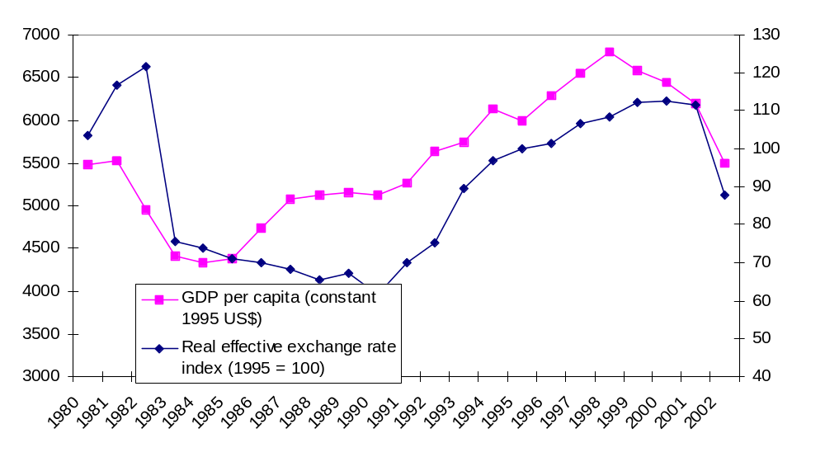
Figure 6

Compare this experience with Chile’s since the mid-1980s. Chile was able to sustain its real exchange rate depreciation following the financial crisis of 1982-83 well into the late 1990s. As of 2002, its currency remained significantly more competitive than it had been in the late 1970s and early 1980s (see Figure 7). In Uruguay, by contrast, the gain in competitiveness had almost all been given up by 2001 due to the real appreciation of the 1990s. This contrast between Uruguay and Chile illustrates an important empirical regularity: growth take-offs take place in the context of sustained real exchange rate depreciations and are associated with sustained export growth (Hausmann, Pritchett and Rodrik, 2004).

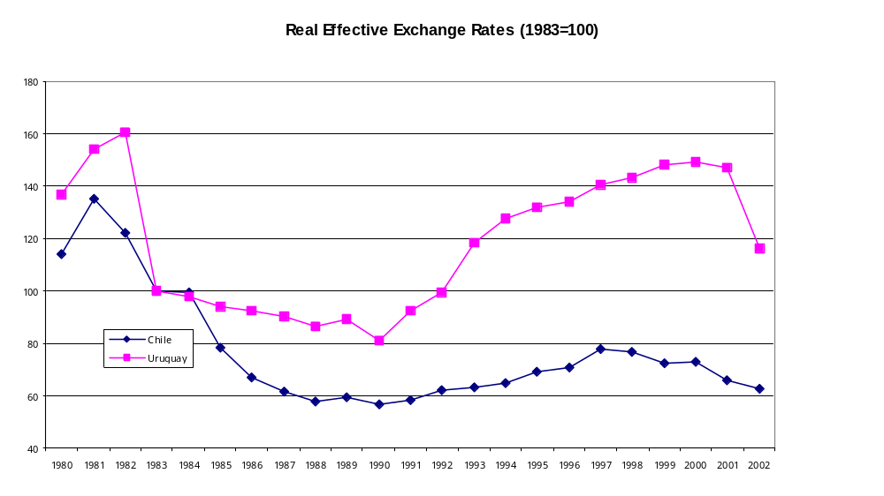
Figure 7

It is important to inquire about what causes the appreciation of the real exchange rate. The common intuition is that as aggregate demand increases, it raises the demand both for tradables and non-tradables. However, the demand for tradables can be elastically supplied through imports, while non-tradables need to be produced domestically. If there are fixed factors in the production of non-tradables – such as fixed capital or land – then increased supply will require a rise in the relative price of non-tradables. The opposite happens when aggregate demand collapses. Now, Chile’s aggregate demand increased faster than Uruguay’s and for much of the 1990s Chile ran a larger current account deficit. Why did this not generate an even faster real appreciation in Chile?

One explanation has to do with the sources of demand for “non-tradables” in Uruguay, as opposed to Chile. Uruguay is a country that is deeply integrated into the Argentine economy. A rise in Argentine demand will spill over into demand for goods and services in Uruguay. Tourism is a case in point, but so are services in general. As a consequence, major fluctuations in economic activity in Argentina will drive changes in the demand for these “non-tradables” in Uruguay. This can be seen by graphing the real exchange rate of Uruguay and Argentine GDP (Figure 8). The graph shows an impressive covariance between these two variables. Between 1983 and 1990, Uruguay’s RER remained at depreciated levels with no signs of appreciation. However, with the stabilization of the Argentine economy and the growth and appreciation process that ensued, the Uruguayan peso quickly started to appreciate.

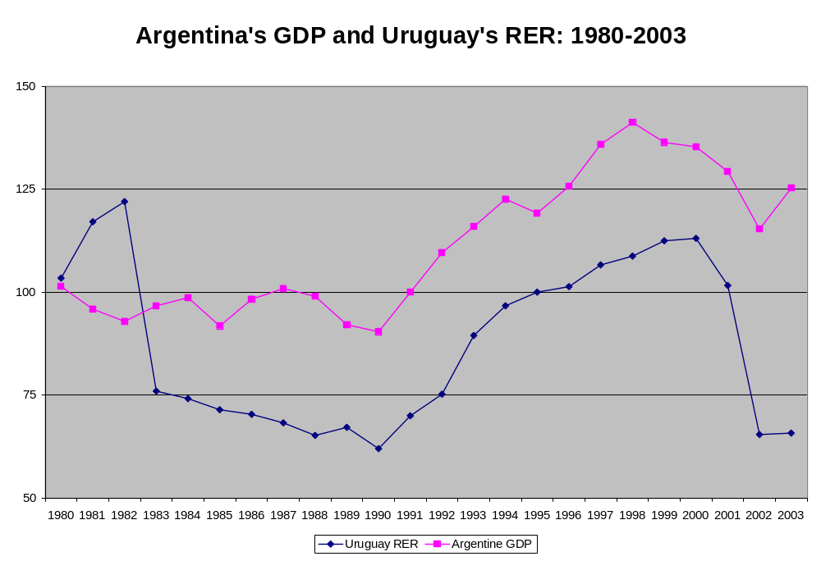
Figure 8

In this respect, one hypothesis is that Uruguay suffers from a peculiar form of Dutch Disease. Instead of having a volatile petroleum sector which causes movements in aggregate demand that affect the real exchange rate, these fluctuations come from Argentine demand for goods that would otherwise only be sold in the local market. This logic is also consistent with a large correlation between the real exchange rates of Uruguay and Argentina.

The Dutch Disease and the concavity of the production possibility frontier

It has been common to assume that an improvement in the terms of trade, or in Argentine demand, necessarily leads to real appreciation. However, it is important to understand what lies behind this connection. To shed some light on this issue, we will start with a benchmark model in which this is not the case.

Assume that both tradables and non-tradables are produced with capital and labor with a constant-returns-to-scale (CRS) technology. Assume further that capital is perfectly mobile internationally. Obviously, this assumption implies that this benchmark should be considered relevant only for the medium term, when capital has had the time to adjust to the level that would equalize domestic and international returns. Under these assumptions the real exchange rate is not affected by shifts in demand because the supply of non-tradables is infinitely elastic and the Production Possibilities Frontier (PPF) is flat. An increase in the demand for non-tradables would be accommodated by getting more workers from the tradable sector and more capital from abroad. Since the technology is CRS, this implies no increase in marginal costs and hence in relative price. The economy adjusts through changes in the composition of output without changes in relative prices.

In this medium-term framework, the real exchange rate should move very little unless there are large differential technology shifts between tradables and non-tradables, which would shift the slope of the PPF. Shocks to the terms of trade would not affect the real exchange rate, only the composition of output.

The idea that shocks to the terms of trade leads to real appreciation is predicated on the idea that factors of production – international capital and domestic labor in this case – move slowly to adjust to shocks. However, in this case, fluctuations of the RER would be temporary and the RER would return to its long-run equilibrium level once the adjustment has taken place, independently of the terms of trade.

But we know that the low-frequency (5-year) real exchange rate in Uruguay is very volatile, even by the standards of developing countries as shown in Figure 5. The obvious question is what is missing from the benchmark model that can account for this low-frequency volatility? One element would be fixed factors. If besides capital (which can be moved and accumulated) and labor there is another factor whose supply is fixed or quasi-fixed, such as land, air, fresh water, etc., this will make the PPF concave. Movements along the PPF now require changes in the RER. An increase in the production of non-tradables will require an appreciation of the real exchange rate (RER). In addition, changes in the RER will not only shift production, but also affect the composition of demand: a real appreciation will shift demand away from non-tradables, thus facilitating the return to balance in the market for non-tradables.

Data shows that developing countries have on average an RER which is about 2.5 times more volatile than that of industrial countries. Shocks to this volatility are also much more persistent (Hausmann, Panizza and Rigobon, 2004a). The cause of this is still unclear. Obviously, the greater reliance on natural resources might explain the presence of decreasing returns and hence a more concave PPF. However, since natural-resource-intensive sectors tend to be capital intensive and tradable, while generating little employment, it is unlikely that they would create much concavity in the aggregate PPF.

An alternative hypothesis is that something makes capital less mobile in developing countries. Hausmann, Panizza and Rigobon (2004b) propose such a model. They assume that there is some financial or investment imperfection that causes investors to behave as if they were more risk averse. The idea is predicated on the notion that in a world of complete markets, risk-averse individuals would behave as if they were risk neutral because they would be able to hedge any undesired risk. They conjecture that the more incomplete the market, the more behavior will be affected by risk aversion.

This assumption introduces an interesting and perverse dynamic. The more volatile the RER, the riskier it is to invest, especially in tradables. If there is risk aversion, this will imply a higher required expected return and a lower level of investment in tradables. This makes the economy more closed.

Now, most open-economy macro models have the property that the more closed the economy, i.e. the smaller the tradable sector, the bigger the required shift in the RER for any given shock (Calvo, Izquierdo and Talvi, 2003). These two forces constitute a positive feedback or multiplier which may trap the economy in a vicious circle in which the RER is volatile because the economy is closed, but the economy is closed because the volatility in the RER makes it too risky to invest in tradables. In a dynamic setting this makes the stock of capital less responsive to real shocks and consequently the real exchange rate must do more of the adjustment, meaning that it needs to be more volatile.

Hence, the volatility of the real exchange rate in Uruguay may be part of a more serious ailment. The country may be trapped in a bad equilibrium in which investors are reticent to invest in clear opportunities in the tradable sector because they fear that the exchange rate may move so as to make the investment unprofitable. This causes the tradable sector to be relatively small and concentrated in activities where economic rents, arising from natural resources, provide a cushion that allows them to survive RER fluctuations. This may explain why in our recent visit to Uruguay we found so many investment ideas in tradables that could be harvested at the current RER.

In this framework, we can distinguish between first-best and second-best policies. The former involve interventions that complete the financial and investment markets so that investors behavior becomes less risk averse. Second best policies involve transferring the risk faced by the tradable sector to the rest of society. By so doing, investment in tradables would go up and the volatility of the real exchange rate would decline, an externality that private investors fail to take into account. We shall come back to policy recommendations below, but before we would like to delve deeper on the connection between the RER and growth.

The level of the real exchange rate and the growth process

The level and volatility of the RER affect growth in several ways. Obviously, a stable and predictable macro environment will facilitate a smoother functioning of the economy and make investment and growth easier. This is conventional, but may understate the importance of the effect because it does not make it interact with sources long-run growth.

Clearly, a sharp increase in the relative profitability of tradables is an important contributor to igniting and sustaining growth. We are already seeing increased investment activity in Uruguay’s tradables subsequent to the 2002 depreciation. The question is whether this will be sustained. In Uruguay’s previous growth cycles, the eventual appreciation of the real exchange rate has served to choke off tradable activities, rendering growth less sustainable and more susceptible to negative shocks.

We would complement the conventional arguments based on macroeconomic stability with the following microeconomic reasoning based on the importance we place on self-discovery. In a small open economy like Uruguay, the greatest returns to discovering high-productivity activities lie among tradable goods and services. This is so, because such activities can cater to the global market, instead of the small domestic market and hence, each discovery can be scaled to a much larger extent and hence make it much more valuable from a social point of view. In addition, it is harder to create the incentives for self-discovery in the tradable than in the non-tradable sector. This arises from the fact that an innovator in the non-tradable sector –by definition – will start being a monopolist in that activity until he is copied by some other entrant in the local market. This period of monopoly may help create the rents that constitute the pay-off to entrepreneurship. By contrast, the first to produce some tradable good or service in Uruguay will not be the first in the world and hence will be participating in a market where there already is pre-existing competition. Hence, in this sector there is least room for entrepreneurial rents to stimulate experimentation and self-discovery.

In this context, sustained real exchange rate depreciation increases the return to such entrepreneurship and acts as a subsidy to self-discovery in tradables. Its impact on aggregate productivity and economic growth can therefore be sizable. Hausmann, Pritchett and Rodrik (2004) find that growth accelerations tend to occur in periods in which the real exchange rate is significantly more depreciated than in the preceding period.

Real exchange rate volatility and the growth process

Large swings in the real exchange rate are not uncommon in Uruguay. Between 1980 and 2003 the percentage distance between the most appreciated RER (observed in 1982) and the most depreciated RER (observed in 1990) was 96.8 percent. Even if we take 5-year moving averages, in order to capture the idea that investors may be able to look beyond short term fluctuation and look at longer term returns, the percentage difference between maximum and minimum amounts to 63.1 percent.

This fact has two implications. First, real exchange rate volatility directly interferes with the self-discovery process. Following the line of argument by Aghion et al (2004), the fact that self-discovery activities tend to have longer term returns than physical capital investment implies that they face more real exchange rate uncertainty. If the financial system is not developed enough to overcome these risks, self-discovery will be depressed and investment will be concentrated on the accumulation of physical capital to exploit existing ideas. Empirically, Aghion et al (2004) find that real exchange rate volatility is most damaging of growth in developing countries.

Coupled with this finding, the arguments in Hausmann et al (2004b) in which RER volatility reduces the incentives to invest in tradables and hence lowers openness to create a high volatility equilibrium may also involve a low growth equilibrium.

The second implication of the large volatility of the real exchange rate in Uruguay is that it will tend to overwhelm modest microeconomic policy interventions (for example of the type we discussed in the preceding section). The impact of any finely-tuned set of tax and/or subsidy incentive programs is likely to be swamped by large movements in the real exchange rate in either direction. Microeconomic interventions matter less when the real exchange rate is (and stays) super-competitive; they will hardly make a difference when the real exchange appreciates. Today, it may make sense to invest in new seed varieties in rice, to control foot and mouth disease through tracking, to develop forests, plants and ports to export pulp and paper, to promote tourism in third markets and to provide the right institutional framework for the export of software, calling centers and other services. However, if the real exchange rate were to move by 60 percent – as has happened in a sustained manner over 5 year periods in the last 23 years – these activities will make much less sense and the economy will not develop the efforts that will allow these sectors to become productive and competitive.

Here may lie in part the secret of the Chilean experience. After the dramatic collapse of the economy in 1982, Chilean economic policy became focused on preventing real appreciation through a myriad of instruments: crawling bands, massive intervention and sterilization, fiscal austerity, taxes on capital inflows, debt-equity swaps, internalization of the pension fund portfolios and others. Probably, beyond the effectiveness of each instrument lies the fact that investors understood that it was a policy goal of the government to protect the competitiveness and stability of the real exchange rate. This implicit contract may have had a lot to do with the growth experience of Chile vis a vis Argentina and Uruguay.

Managing the real exchange rate

We have argued that the real exchange rate may impact long-run growth through a set of unconventional channels which constitute externalities from the point of view of individual agents. Hence, a market-determined level and volatility of the RER may be socially inefficient and policies should be able to improve on them.

A commitment to a competitive and stable real exchange rate

It is fashionable these days to argue that monetary authorities should declare a commitment to low inflation and to reserve for itself operational discretion as to how to achieve this objective. If the commitment is serious and the set of instruments is powerful enough to achieve its goals, such a statement may also be credible and effective. We argue that the same overall logic applies to the real exchange rate although the policy apparatus may be quite different.

A credible commitment to a competitive and stable real exchange rate would reduce the risk of self-discovery activities and investments in tradables and would increase the effective openness and diversification of the economy. This will reduce RER volatility. In addition, it will lower the relative importance of Argentine demand on the economy further stabilizing the RER. Finally, a more open economy will have a larger political constituency in favor of a competitive and stable RER, thus making its commitments in this area politically more credible.

Moreover, it is clear that what needs to be stabilized is the RER vis a vis global markets and not the regional market, as the latter is smaller, more volatile and less sensitive to the growth externalities we have identified. In addition, in many respects, a large part of the growth potential of Uruguay lies in activities that are substitutes and not complements of Argentine production. This is particularly clear in agriculture but is bound to be the case in other sectors. Hence, these activities would suffer in a world where the bilateral RER with Argentina and Brazil became stable at the expense of volatility in the RER vis a vis global markets.

Hence, we would argue in favor of the idea of making the competitiveness and stability of the RER become a major commitment of the development strategy of Uruguay. It is important to understand the temptations that may pull the country away from this goal. First, from a fiscal and financial point of view, a more appreciated exchange rate –ceteris paribus– implies that the weight of dollar-denominated debt to GDP ratio will be lower. Would this not be a better strategy to improve the financial stability of the country? But ceteris is not paribus. A more depreciated and stable RER will cause GDP and exports to rise faster and the current account to be stronger, leading to both a slower growing numerator and a faster growing denominator. This is bound to lead to a more sustainable reduction in debt ratios.

Second, a more appreciated RER, will lead to a lower price of tradables, such as food, and these enter significantly in the consumption basket of the poor. Would this not be better for welfare? Again, this is a very static argument. A strong RER would lead to higher unemployment and less higher-productivity job creation through the growth and discovery process.

Beyond its desirability, the question is whether a more competitive and stable RER can be achieved through policy? And if so, how? We believe it can and will discuss which policy instruments to use for this purpose. We shall discuss fiscal policy, where the arguments outlined strengthen the case for prudence, and monetary, exchange rate and financial policies, where we depart more from the conventional wisdom.

Fiscal policy

In the long run, the real exchange rate will be impacted by the balance between aggregate supply and aggregate demand. A stronger demand will lead to a more appreciated RER. Fluctuations in aggregate demand will lead to a volatile long-run RER. In a world without full Ricardian equivalence, fiscal policy can play a stabilizing anti-cyclical role. It can go into surplus when other sources of demand – say a temporary Argentine or capital inflows boom – and move into deficit when conditions worsen. However, a necessary condition for this to happen is that the overall solvency of the government be perceived as strong. A government with precarious creditworthiness will not be able to borrow in bad times to cushion the blow or to incur in quasi-fiscal losses at the Central bank as part of a sterilization strategy. In this respect, targeting a cyclically adjusted fiscal surplus, as Chile has been doing lately, would be appropriate. As the surpluses accumulate and the economy grows, debt ratios will decline in a sustained manner and the anticipation of this trend will lower the cost of debt service much sooner. Prudent and anti-cyclical fiscal policies, especially now that the economy is recovering, would contribute to the goal of a competitive and stable RER.

Monetary and exchange rate policy

While in the long run, the RER is affected by aggregate supply and demand balances at full employment, in the short run, both the nominal and the real exchange rate are affected by equilibria in asset markets. In the standard Dornbusch (1976) model, exchange rate overshooting is the product of slow adjustment in the labor market in the context of fast adjustment in financial asset markets. So, what role should monetary and exchange rate policy play in achieving a competitive and stable RER?

The conventional answer is none. It is common to argue that the task of achieving low inflation is so difficult already and the central bank has so few instruments that complicating its task with additional goals would be counter-productive. This is in part based on the idea of the impossible trinity: it is impossible to simultaneously achieve international financial integration, monetary independence and an effective target on the exchange rate. You may achieve two but not three of these goals. With international financial integration you must either choose between an exchange rate target or monetary independence.

This has lead to the bi-polar view of exchange rate policies in which the central bank either pegs fully and credibly to a foreign currency – through dollarization or a currency board – or sets completely flexible exchange rates accompanied with some form of monetary or inflation targeting. After the failure of Argentine convertibility, floating exchange rates with inflation targeting have become the new fashion.

Let us discuss how they work and see how they may interact with conditions for growth and self-discovery in the tradable sector. The standard approach to inflation targeting starts with a central bank that announces its inflation target and adjusts monetary policy in response to inflation expectations. Monetary policy is usually done through an interest rate that the central bank either sets or affects through open market operations. Intervention through interest rates has become more common because the alternative – monetary targets – tended to generate volatility in exchange rates and interest rates associated with the fact that money demand is volatile, but central banks cannot incorporate this source of variation in their money supply decisions.

With inflation targeting, the central bank usually announces that it does not care about the exchange rate except in so far as it may affect inflation expectations. In this context, consider the following three shocks: an expansionary (or irresponsible) fiscal policy, an exogenous capital inflows boom and a boom in Argentina. An expansionary fiscal policy will lead to increased demand and inflationary expectations in the non-tradable market. The central bank would respond with a rise in interest rates which lower domestic demand and would appreciate the exchange rate, lowering the price of importables and exportables and causing a contraction in the tradable sector. This will free up resources to accommodate the increased demand of non-tradables. Through both mechanisms inflation would be moderated, but the tradable sector would face a contraction caused by real appreciation. In other words, monetary policy sacrifices the tradable sector in order to make fiscal irresponsibility compatible with its inflation target.

Consider now a capital inflows boom. Under an inflation targeting regime this will lead to exchange rate appreciation. This may moderate inflationary pressures allowing the central bank to reduce interest rates. The appreciation will lower the price of tradables and will reduce employment, investment and profits in this sector, thus freeing resources that will help expand the supply of non-tradables in order to accommodate the increased demand caused by the lower interest rates. Again, the tradable sector contracts in order to accommodate the capital inflow.

A boom in Argentina will cause an increased demand for regional goods. This will raise inflationary expectations and the central bank would respond with a combination of higher interest rates and a more appreciated exchange rate. Again, the global (i.e. non-regional) tradable sector will contract.

What is common about these three examples is that the tradable sector plays, in this strategy, the role of front-line troops in the battle against inflation. Its expansion and contraction is called upon in order to contain inflation. Even in the case when it is fiscal profligacy that causes the inflationary pressures, the policy solution involves a real appreciation in order to contract, not the non-tradable sector which benefited from the fiscal expansion, but the tradable sector which did not. Under these conditions, the battle for low inflation may be won more easily, but the casualties disproportionally fall in the level and stability of the competitive conditions faced by the tradable sector.

There is an added complication with the regime of inflation targeting when it is implemented in a country characterized by liability dollarization, such as Uruguay. Under these conditions, exchange rate fluctuations cause balance sheet effects that make a monetary expansion either less effective. When the central bank adopts an expansionary (contractionary) monetary policy, the concomitant exchange rate depreciation (appreciation) causes an adverse (favorable) balance sheet effect, making the impact less expansionary, or even contractionary (less contractionary or even expansionary). The balance sheet channel works against the normal channels of monetary policy limiting its impact on aggregate demand and forcing the central bank into larger interest rate movements (and hence real exchange rate changes) to achieve the same demand effect.

In addition, a pure floating regime would involve no exchange rate intervention which means that the level of international reserves is not used to accommodate shocks to the demand for money. Instead these get absorbed by the exchange rate and the interest rate, making them more volatile. It would be ideal to use the level of reserves to absorb at least part of that volatility so as to leave a more stable RER environment, but a pure inflation targeting scheme does not have a clear policy rule on how to do this.

For all these reasons, we believe that standard inflation targeting would not lead to a stable and competitive RER. Instead, it is bound to create too much RER and interest rate risk, and lead to other undesirable results, forcing the central bank into a series of modifications and ad hoc adjustments without a coherent policy, as for example, in Colombia.

We propose instead to complement a pure inflation targeting scheme with a loose real exchange rate commitment both by the fiscal and monetary authorities and more activism on the side of financial and capital account policies. Fiscal policy should be set with an eye on the competitiveness and the stability of the real exchange rate. This can be achieved with a cyclically-adjusted fiscal surplus, as argued above. Monetary policy should allow the exchange rate to float but should announce a central parity. It should be ready to intervene in the exchange rate market when it feels the deviations are inconvenient. It need not announce a band, as this could create destabilizing speculation around the edges of the band.

The underlying model behind this strategy assumes that the central bank cares not only about inflation and output today, but also about growth tomorrow, which is affected by the level and stability of the real exchange rate. Hence, the central bank needs to express a target for the real exchange rate and develop instruments to reach it. This is what we shall discuss below.

What should the central bank be ready to do when there are what it deems to be excessive pressures towards real appreciation? The first order of business would be, of course, simple unsterilized intervention, i.e. with the purchase of international reserves with cash. This will expand base money and cause a reduction in interest rates. As the rates decline, capital will stop flowing in. However, the base money created in the process may lead to a credit boom which may potentially create expansionary pressures at home and cause inflation to accelerate with its negative effects on inflation and competitiveness. This risk should not be exaggerated. Consider, for example, the case of China. The country has purchased some US$ 480 billion in unsterilized international reserves and after a long period in which markets feared deflation, prices in 2004 are now rising at a rate of 5 percent forcing the government to take action. However, this has not taken place through currency appreciation. Instead credit and public enterprise policies have been tightened. The point is that a policy of unsterilized intervention will at worst create inflationary pressures that are bound to happen gradually, through pressures in the labor market instead of suddenly through real appreciation. As they take place, there may be time to respond to them through other policies.

One alternative to unsterilized intervention is sterilized intervention, i.e. the purchase of international reserves but accompanied with an open market operation designed to limit the expansionary effect on the supply of money. We are less enthusiastic about this policy: it will lead to a potentially large quasi-fiscal deficit and may become unsustainable as it tends to keep interest rates high which will attract more speculative capital inflows. In the end, it may be expensive and ineffective.

Instead, we would propose to contain aggregate demand pressures through other means. Besides fiscal policy, already mentioned above, financial policies may help. An alternative to sterilization through open market operations is reserve requirements on banks. If sterilization leads to an expansion of monetary aggregates that are deemed too high and unsustainable, the central bank can act to lower the money multiplier. One way to do this is through increased reserve requirements. This will finance indirectly the purchase of international reserves by the central bank, but as opposed to sterilization, will lower deposit interest rates which will dampen capital inflows. These reserve requirements may or may not be remunerated, but the rate at which they are should be below the deposit rate.

Another instrument is the adjustment of capital adequacy requirements on banks. The expansionary effects of unsterilized intervention on bank credit can be limited by requiring banks to back up their credit with more of their own capital. This makes prudential sense because it will limit credit booms, which often end in tears. Moreover, it will make the capital adequacy requirement part of an anti-cyclical policy stance which is prudentially sound: when the external environment turns less buoyant, banks will have the capital base to face the coming difficulties.

An additional mechanism is to opportunistically fight liability dollarization in good times. When capital inflows threaten real appreciation, prudential norms regarding foreign borrowing of banks can be tightened. Foreign bank loans should under any circumstance be subject to reserve requirements. This will act as the equivalent of a tax on capital inflows, which can be adjusted given the circumstances. Dollar lending to non-tradable activities must generate a higher capital adequacy requirement in order to cover the implicit currency risk. This will limit the expansion of credit to the booming non-tradable sector while it will protect financial conditions in the tradable sector. If this is done effectively in good times, when the situation turns sour, the balance sheet effects will be that much smaller and the situation that much more stable.

In short, prudential norms on foreign borrowing by Uruguayan banks can act as implicit capital controls while prudential norms on foreign currency lending can be used in a prudentially sound manner to avoid over-valuation.

In addition, foreign investment rules on pension funds can be adjusted to fight real appreciation. If capital inflows are excessive, foreign investment restrictions can be opportunistically relaxed. Internationalizing the portfolio of pension funds makes sense in order to protect workers from the volatility in the local market. Doing this in bad times is impractical, as it would exacerbate external imbalances. But in good times, it allows to achieve a long-term goal while contributing to shorter term stability of the RER. As the experience of Chile shows, there is an additional benefit of allowing pension funds to invest abroad: they will help develop the market for long term currency hedges. As the liabilities of the pension funds are in pesos and part of their assets will be in dollars, they will want to enter long term currency swaps in order to protect their returns from an unexpected appreciation in the RER. This is the opposite fear of the one faced by dollar borrowers. The development of this market may help reduce and better distribute the currency risks caused by liability dollarization.

In synthesis, the central bank and the government can fight what they deem to be unwarranted real appreciation through an arsenal of potential tools that include fiscal contraction, unsterilized intervention, reserve requirements, capital adequacy requirements, requirements on foreign borrowing and the regulation of pension funds. The commitment to keep the RER stable and competitive need not involve a fixed RER with zero risk. The actual RER will fluctuate around the announced target. Instead, the target should be viewed as an implicit contract which signals the government’s intention and gives a sense of priority to its macroeconomic strategy.

The authorities can review their RER target in line with new information. For example, if the country has a tight labor market in the context of a current account surplus and relatively low terms of trade, this would constitute prima facie evidence that the RER is undervalued. But if unemployment is above its natural rate then it should wait until it expects it to come down before announcing a move in the RER target. If the current account is in deficit, or if it is in a surplus attributable to unusually favorable temporary external conditions, it should not move its target.

In addition, the authorities should treat the RER target as indicative and should not commit to any given band around the target. Through time the authorities and the market will learn about the effectiveness of its instruments and the credibility of its stance. If it is successful, the market will help achieve the target through stabilizing speculation, a la Krugman (1988).

With this approach we believe that the RER volatility of past years can be significantly mitigated. If successful, the country will grow out of its volatility problem through increased openness and diversification. In the meantime, a clear commitment to a stable and competitive RER is a key element for the strategy of structural transformation.

Exchanging RER risk

The policies described in the previous subsection attempt to reduce RER volatility by using macroeconomic policies. In this section we discuss interventions designed to lower the RER risk faced by certain activities in the tradable sector, without affecting the RER itself. These policies are based in transferring or exchanging the existing risk.

The simplest example is currency swaps. The Uruguayan government has the bulk of its debt denominated in US dollars. As such it fears a real depreciation, since it would increase the debt service burden. By contrast, the tradable sector fears a real appreciation, since it would increase costs and lower prices. Both parties can solve the problem by exchanging the currency risks through a forward contract. The government gives up its potential gains from a real appreciation in exchange for avoiding the potential losses caused by a real depreciation. The tradable sector could do the opposite.

This market does not exist in Uruguay, but it is in the double interest of the government that this market take off since it would lower its own debt service risk and would promote tradable development by allowing the sector to hedge its RER risk. It can kill two birds with one stone because it can exploit the fact that the tradable sector has the opposite financial risk to its own. An equivalent market can be generated or stimulated using options instead of forwards.

It is improbable that a deep market will develop any time soon and when it does it will very short-run relative to the risks faced by new tradable activities. However, the government should be willing to enter into over-the-counter deals for investors in these activities as a way to insure them against real RER appreciation. One example would be to offer out-of-the money RER puts on their future dollar exports. This will reduce the risk of investors but would only become a fiscal cost at a time when RER appreciation had made the debt service burden smaller.
Bibliography

Aghion, P. G.M. Angeletos, A. Banerjee and K. Manova (2004) “Volatility and Growth: Financial Development and Cyclical Composition of Investment” (mimeo), Harvard University.

Audretsch and Feldman, 2003: “Knowledge Spillovers and the Geography of Innovation,” forthcoming in the Handbook of Urban and Regional Economics, Volume 4, North Holland.
Dornbusch, Rudiger, 1976, "Expectations and Exchange Rate Dynamics," Journal of Political Economy, Vol. 84, pp. 1161-76.

Hausmann, R., and D. Rodrik, “Economic Development as Self-Discovery, Journal of Development Economics, December 2003.

Hausmann, R., L. Pritchett, and D. Rodrik, “Growth Accelerations,” Harvard University, 2004.

Hausmann, R., U. Panizza and R. Rigobon (2004a) “The Long-Run Volatility Puzzle of the Real Exchange Rate”, NBER WP# 10751.

Hausmann, R., U. Panizza and R. Rigobon (2004b) “Financial Imperfections and the Long-Run Volatility of the Real Exchange Rate”, (mimeo), Harvard University.

Koren, M. and S. Tenreyro (2004) “Technological diversification, volatility and development” (mimeo) Harvard.

Krugman, P., (1988) "Target Zones and Exchange Rate Dynamics," NBER Working Paper No. W2481.

Rodríguez-Clare, A. (2004a) “Microeconomic Interventions after the Washington Consensus,” Research Department, Inter-American Development Bank, August.

Rodríguez-Clare, A. (2004b) “Clusters and Comparative Advantage: Implications for Industrial Policy,” Research Department, Inter-American Development Bank, October.

Rodrik, D. (2004) “Industrial Policy for the Twenty-First Century,” Harvard University, October.

This is a report prepared for the Inter-American Development Bank. We thank Eduardo Fernandez-Arias for his guidance and comments all along the way.
We use Penn World Tables definition of GDP and population.
This reflects the fact that the collapse in 1982-84 was larger than in 2002. Per capita growth from the trough-year of 1984 to the peak-year of 1998 was a respectable 3 percent. Obviously, this last measure is questionable as it mixes recovery with long-run growth.
Hausmann, Panizza and Rigobon (2004) study the negative two-way relationship between real exchange rate volatility and openness.
According to the Economist Intelligence Unit’s Commercial Guide on Uruguay, “To date, the largest promoted project was a remodeling of Montevideo’s horseracing stadium submitted by Hípica Rioplatense Uruguay. The project, which was opened to the public at end-2003, cost US$21.2m. The company—made up of Argentinian and US investors—was allowed to import equipment worth US$1.2m duty free. Goods and services worth US$15.7m are exempt from the industry and commerce income tax for five years and all intangible goods and fixed assets involved in the project are tax exempt for five years.
Under the WTO’s Agreement on Subsidies and Countervailing Measures, Zona Francas are seen as export subsidies and thereby are scheduled for elimination in 2009 by all developing countries with income per capita levels above $1,000. This agreement applies only to manufactures, however, so this does not present a problem for Uruguay given that in practice the regime has specialized in services.
Readers interested in getting a more complete picture of the NIS in Uruguay can consult http://www.dinacyt.gub.uy.
The PDT has three components. The first component is the one already mentioned; it entails the distribution of funds to individual enterprises or groups of firms for the financing of research. The second component is directed to strengthening the country’s capabilities in research (i.e., the research supply side). The third component directs funds to improve the effectiveness of the whole innovation system, and mainly entails strengthening DINACYT. In contrast to previous efforts, one key element in allocating funds for the research community under the second component is the economic relevance of the research. To implement this, a committee is in charge of defining “areas of opportunity” which research could generate larger social returns.
Interested readers can consult http://amsudpasteur.edu.uy/.
http://www.uruguayxxi.gub.uy/2002/english/inversiones/directorio/centro.html
We put “non-tradables” in quotations because we refer to activities that cannot be imported or exported, such as construction and services, but that due to that can be sold in Uruguay to Argentineans.
See for example, Lorenzo, F., Noya, N., Daude, C., 2001. Tipos de Cambio Reales Bilaterales y Volatilidad: La Experiencia Uruguaya con los Socios del MERCOSUR, in J.M. Fanelli (ed.) Coordinación de Políticas Macroeconómicas en el MERCOSUR, Buenos Aires, Siglo XXI.
Profits in tradables are more sensitive to real exchange rate fluctuations because RER appreciations (depreciations) imply a falling (rising) relative price of tradables but are often accompanied by rising (falling) wages. Since prices and costs move in opposite directions this increases the instability in profits. By contrast, in the non-tradable sector there tends to be a positive correlation between prices and wages, thus stabilizing profits. A sufficient condition for this to hold is that the tradable sector be more capital intensive than the non-tradable sector.
Koren and Tenreyro (2004) propose an alternative mechanism through which RER volatility would lead to lower growth. They argue both theoretically and empirically that the high RER volatility in developing countries is the product of low diversification into differentiated intermediate inputs, as firms will have more difficulty in responding to any shock to any given input. If investment in intermediates is thwarted by high volatility and at the same time increases it, this may constitute another form of a low growth trap.

