UNIVERSITY OF CALIFORNIA, BERKELEY
SANTA BARBARA • SANTA CRUZ

BERKELEY • DAVIS • IRVINE • LOS ANGELES • MERCED • RIVERSIDE • SAN DIEGO • SAN FRANCISCO

DEPARTMENT OF ECONOMICS

530 EVANS HALL #3880
BERKELEY, CA 94720-3880
PHONE: 510-642-0822/ FAX 642-6615

February 7, 2019

To Whom It May Concern:

Economics 100B, Intermediate Macroeconomic Theory, will hold its midterms in the evenings
Midterm #1, Thursday February 21, 7:00 – 8:30 pm
Midterm #2, Thursday, April 4, 7:00 – 8:30 pm

There are no alternative times for the midterms, which are required for the course.

Please provide accommodation for this student.

I can be contacted at 510-642-6083 or olney@berkeley.edu. The course website is available at https://eml.berkeley.edu/~olney/spring19/econ100b/

Sincerely,
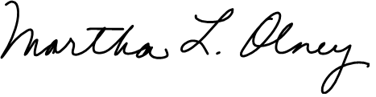

Martha L. Olney
Economics 100B Instructor
Teaching Professor
Undergraduate Chair
Department of Economics

